Manual for MassSpec Python Package (v1.0.0)

Welcome to the MassSpec Python Package! This document provides clear, step-by-step instructions on when and how to use each function in the MassSpec Python Package.

Contents

Instructions Functions 1

Background Subtractor 1

Intensity over time 2

Single Waveform Analysis 4

Calibration 6

## Instructions Functions

All MassSpec functions support custom window resizing and saving your configuration:

1. Click **Settings**.
2. Adjust the slider to the desired value.
3. Click **Save** to store your preferences.

Each tool also allows exporting the processed data alongside generated plots.

Figure 1: Scaling example

**Data Structure Requirement**

All functions expect input data in the default Acqiris software format: a directory containing measurement files organized by acquisition (see Figure 2).

Figure 2: Example structure of a required measurement folder.

### Background Subtractor

***When to use:***

This function calculates the difference between two summed up measurements. Therefore, it first sums each measurement folder up and afterwards takes the difference between them. This allows the user to subtract a background from the desired mass spectrum. This will reduce the noise.

**Attention**: Both measurements must have identical acquisition times.

***How to launch:***

import massspec_package

massspec_package.launch_background_subtractor()

***How to use:***

Use the controls labeled (1) and (2) to choose your two measurement folders (see Figure 3). Once both folders are selected, click the **Process & Plot** button (3) to begin.

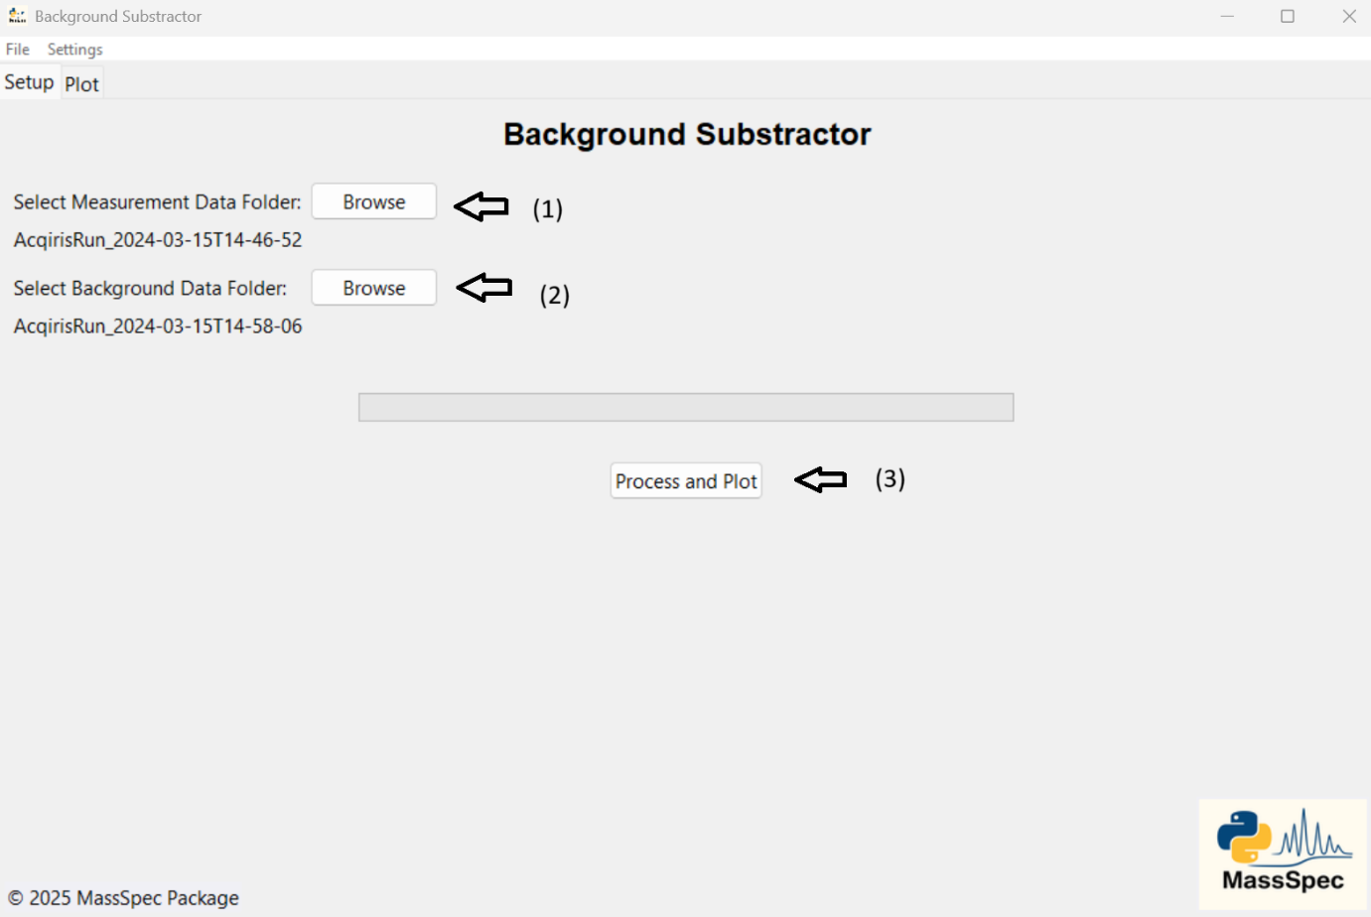

Figure 3: Setup tab of the background subtractor

When processing finishes, the interface automatically opens a new tab showing the calibrated mass spectrum. Above the plot, you’ll find a **Save Data** button—click it to export the numerical data behind the graph.

### Intensity over time

***When to use:***

Track signal stability by extracting the maximum intensity from each measurement in a folder.

***How to launch:***

import massspec_package

massspec_package.launch_intensity_over_time()

***How to use:***

First select a measurement folder where the single measurements are stored (1) (see Figure 4).

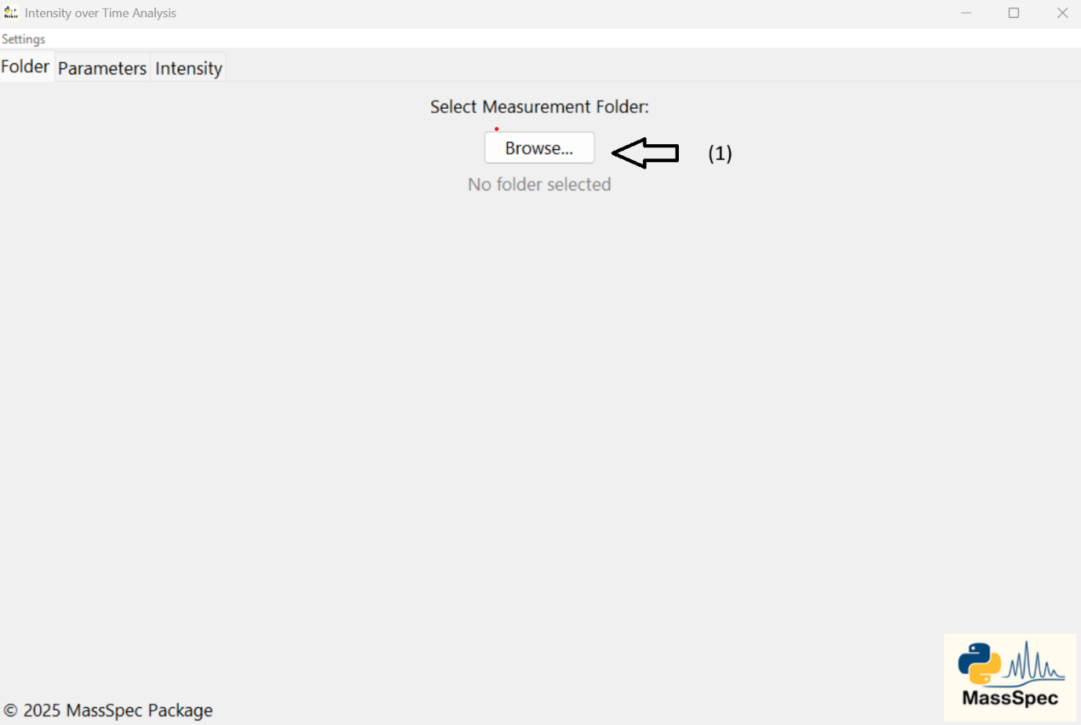

Figure 4: Folder tab of the Intensity over Time Analysis

After you select a folder, the interface automatically switches to the second tab and displays the first measurement from that folder. This preview plot lets you choose the window boundaries that define the region within which the program will find the maximum intensity in each subsequent measurement. Narrowing the window is important to avoid early‐spectrum pulser noise or to focus on a specific mass peak (see Figure 5).

* **Adjust boundaries (1) and (3):** Drag the left and right markers to set your window.
* **Skip initial scans (2):** Enter the number of first measurements to ignore (default is 0).
* **Run calculation (4):** Once you’re happy with your window and skip settings, click “Calculate” to process all measurements in the folder.

The selected window will be highlighted on the plot, and the software will report the maximum intensity within that region for each file.

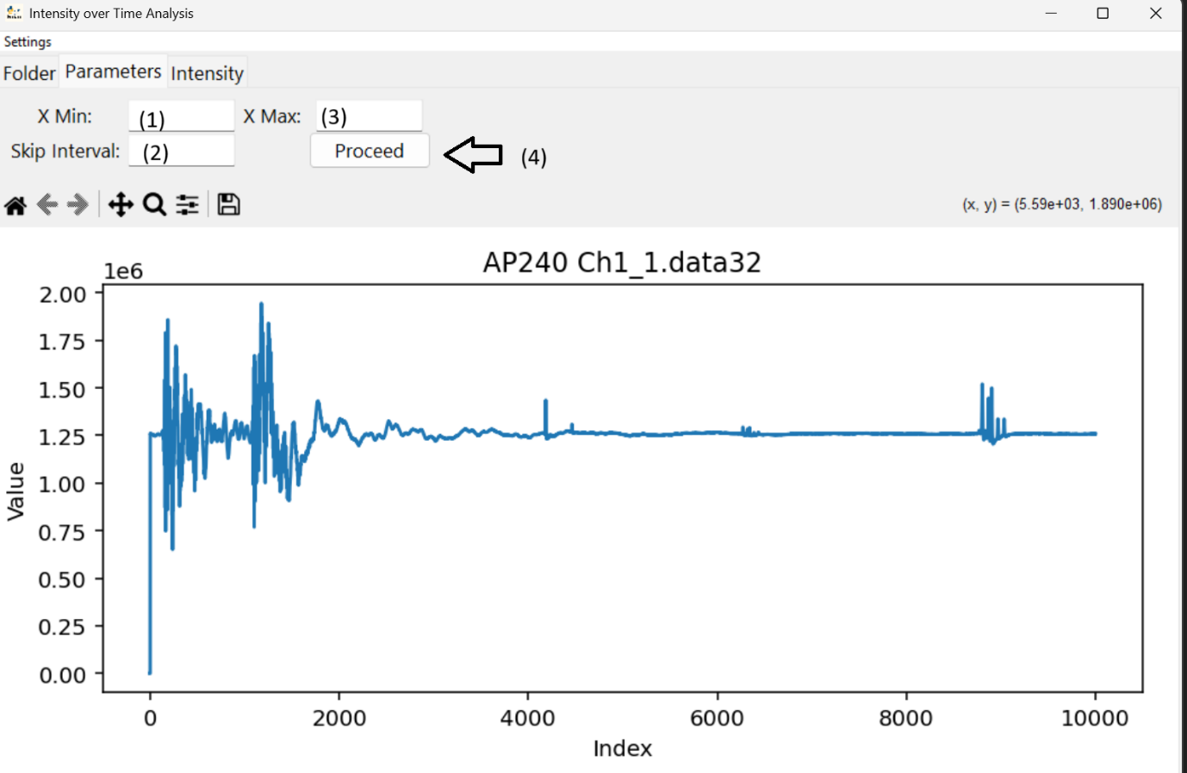

Figure 5: Parameters tab of the Intensity over Time Analysis

### Single Waveform Analysis

***When to use:***

This tool allows the user to compare single waveforms inside the measurement folder to each other.

***How to launch:***

import massspec_package

massspec_package.launch_single_waveform_analysis()

***How to use:***

Use the **Browse** button (1) to choose a folder (see Figure 6). The interface will then list every waveform file it contains. Click a filename to toggle its selection (or press Ctrl + A to select them all). When your selection is ready, click **Confirm** (2) to generate the plot.

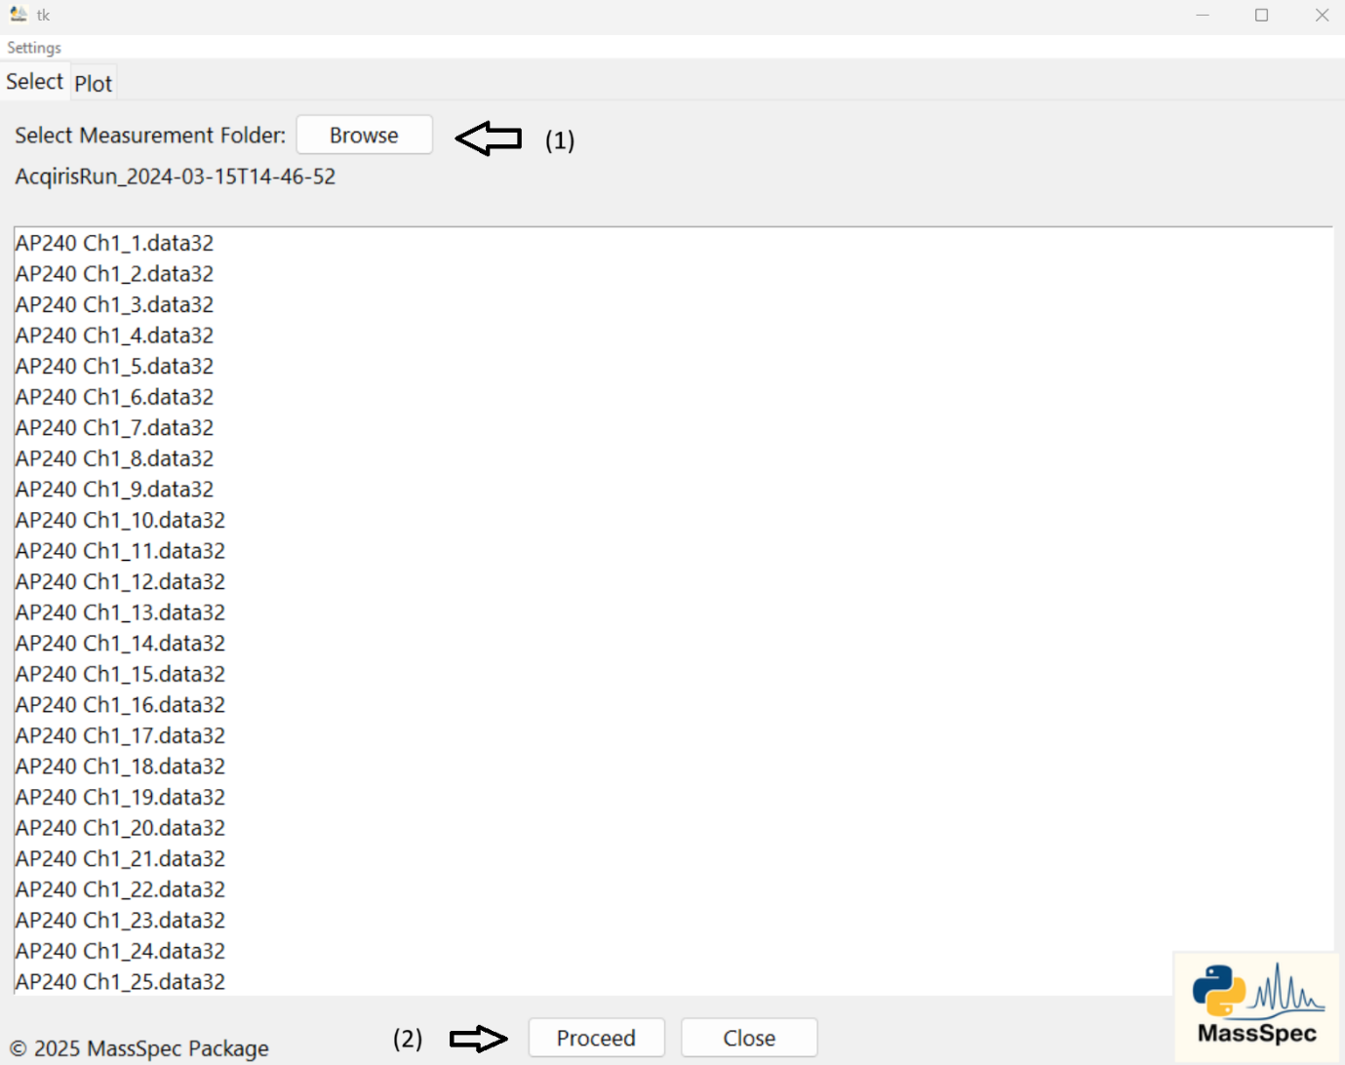

Figure 6: Selection tab of Single Waveform Analysis

With control (1), choose where the legend appears—or turn it off entirely (see Figure 7):

* **Inside Plot:** Renders the legend overlaid on the chart.
* **Separate Window:** Opens the legend in its own dialog.
* **None:** Hides the legend.

These options help manage clutter when you’ve plotted many waveforms.

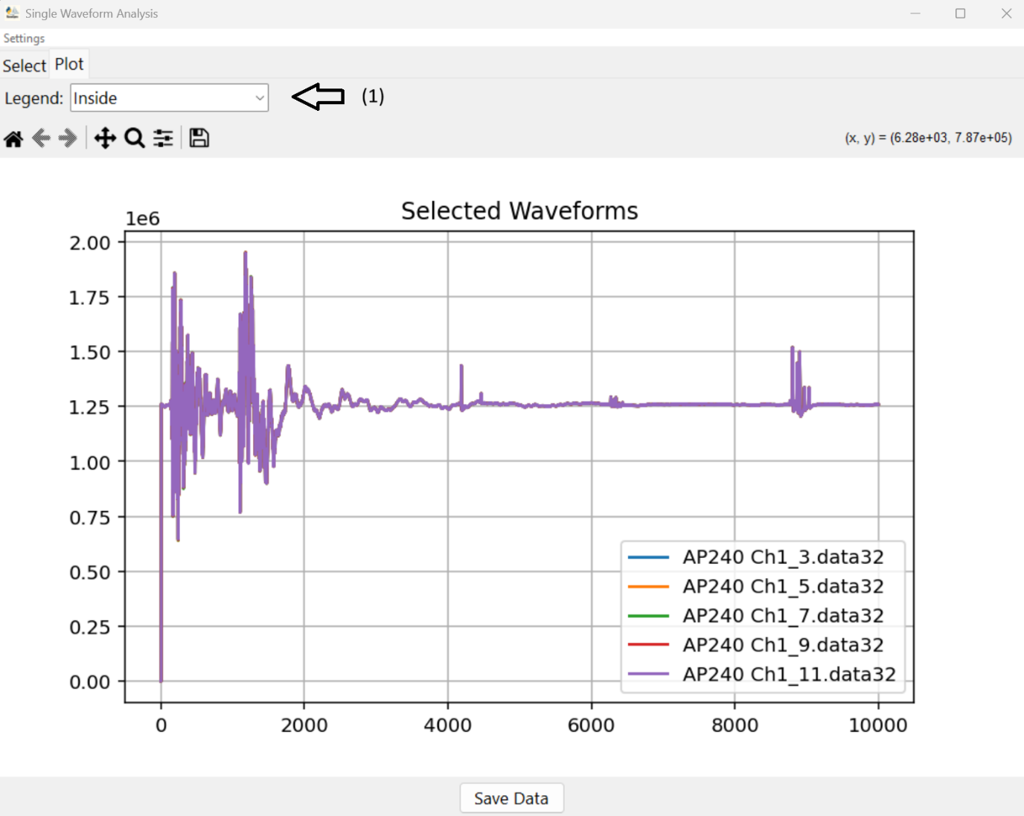

Figure 7: Plot tab of Single Waveform Analysis

### Calibration

***When to use:***

This tool lets you calibrate both axes—or just the X-axis if you prefer.

* **Y-axis calibration:**
  + **Relative Intensity:** Scales all signals so the tallest mass peak equals 100%.
  + **Partial Pressure (mbar):** Converts signal intensity to absolute pressure for each species.
* **X-axis calibration only:** If you only need to adjust the time-to-m/z conversion, skip Y-axis settings and proceed directly to X-axis calibration.

***How to launch:***

import massspec_package

massspec_package.launch_calibration()

***How to use:***

Begin by choosing your **measurement folder** (1) and **background folder** (2) (see Figure 8). Next, pick one of the three Y-axis calibration modes (3):

* **None:** Leave the raw intensity values unchanged.
* **Absolute Pressure:** Convert intensities into total instrument pressure (mbar).
* **Normalize to 100:** Scale the spectrum so that the tallest peak equals 100%—a standard way to display mass spectra.

When you’ve set your folders and Y-axis mode, click **Process & Plot** (4). After the progress bar completes, you’ll be taken to the second tab, which shows the uncalibrated data plot.

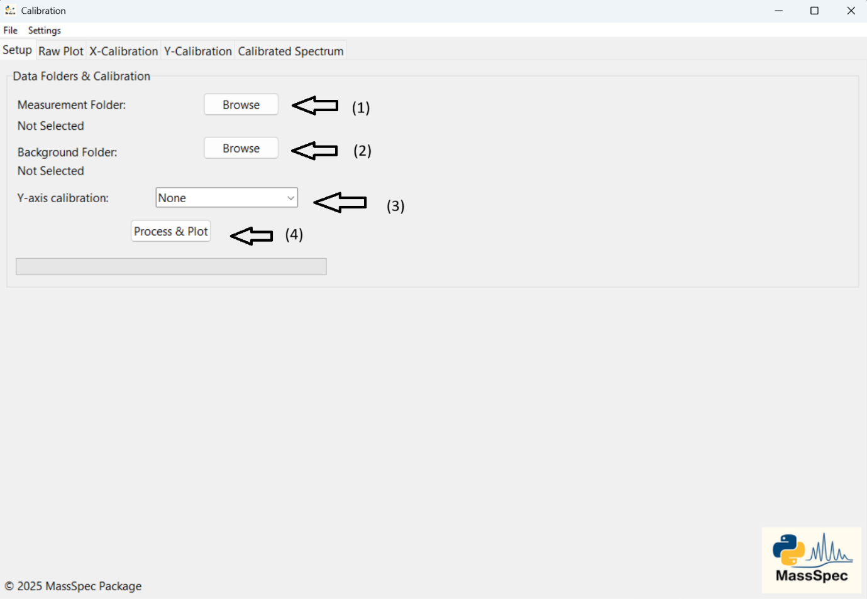

Figure 8: Setup tab of Calibration

When you’re happy with the spectrum you want to calibrate, click **Edit/Calibrate** to begin the X-axis calibration. You’ll be taken to the **X-Calibration** tab (see Figure 9), which presents four input fields:

1. **T1 & T2 (ADC time):**
   * Represent two points on the raw time axis.
   * Shown as red dotted lines on the plot.
2. **m1 & m2 (m/z values):**
   * The true mass-to-charge ratios corresponding to T1 and T2.

**Updated workflow:**

* You can now simply click on the plot at your desired positions to set **T1** and **T2** automatically.
* Use the zoom tool in the toolbar to zoom in on peaks for precise placement.

Once you’ve defined T1, m1, T2, and m2, click **Apply** (2) to confirm and generate your calibrated spectrum.

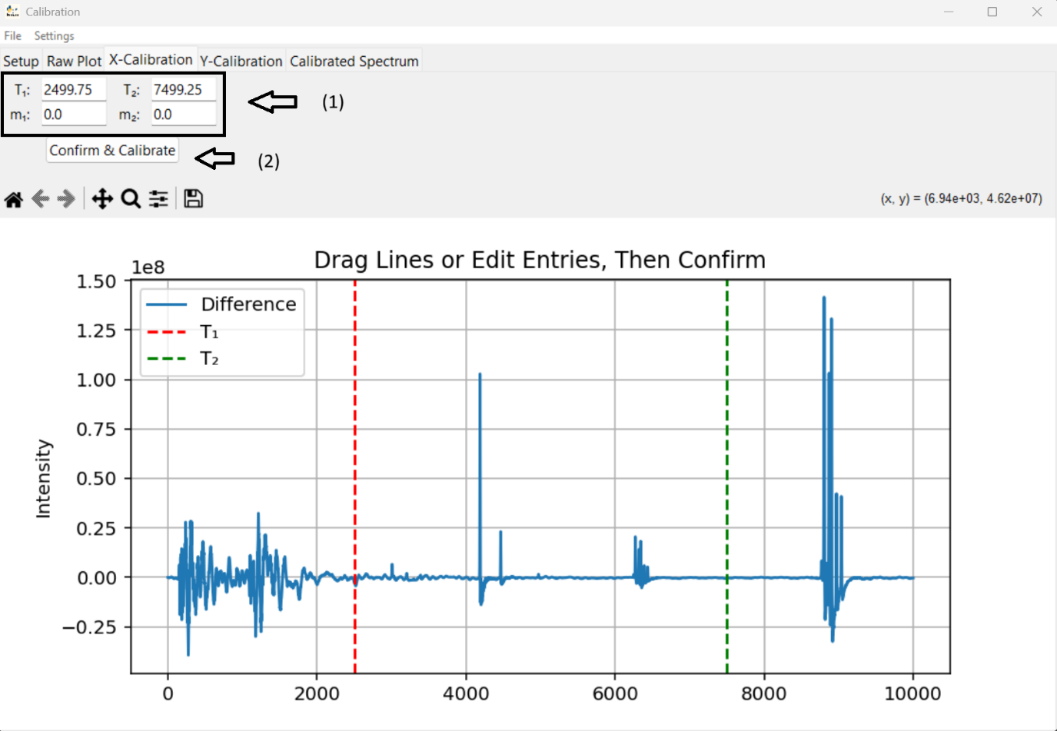

Figure 9: X-Calibration tab of Calibration

If you chose **None** for Y-axis calibration, the program skips directly to the **Calibrated Spectrum** tab and displays your spectrum with only the X-axis calibrated. If you selected **Absolute Pressure** or **Normalize to 100**, you’ll land on the **Y-Calibration** tab (see Figure 10), which requires three inputs:

1. **Detection Threshold (1):**  
   Enter the minimum peak height. Only peaks above this value will be detected.
2. **Detection Boundaries (2):**  
   Define the m/z range to search for peaks—useful for excluding low-m/z pulser noise.
3. **Instrument Pressure (3):**  
   (Absolute Pressure mode only) Enter the measured pressure in mbar.

Once your parameters are set:

1. Click **Detect Peaks** (4) to run the peak finder.
2. If you’re satisfied with the detected peaks, click **Apply Calibration** (5) to generate the final, fully calibrated spectrum.

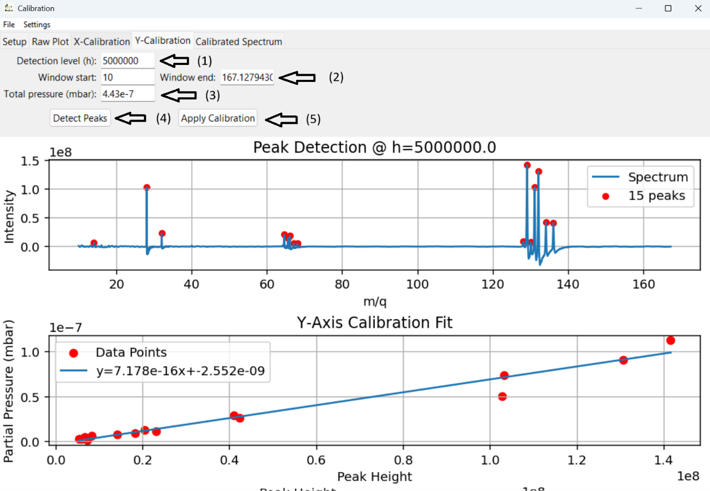

Figure 10: Y-Calibration tab of Calibration

The **Final Spectrum** tab (see Figure 11) displays your fully calibrated mass spectrum. Use the controls at (1) to:

* **Edit Title:** Customize the plot title.
* **Save Data:** Export calibrated values.
* **Log Scale:** Toggle a logarithmic Y-axis.
* **...**

Thank you for choosing MassSpec! For bugs or feature requests, please visit our GitHub repository and open an issue.

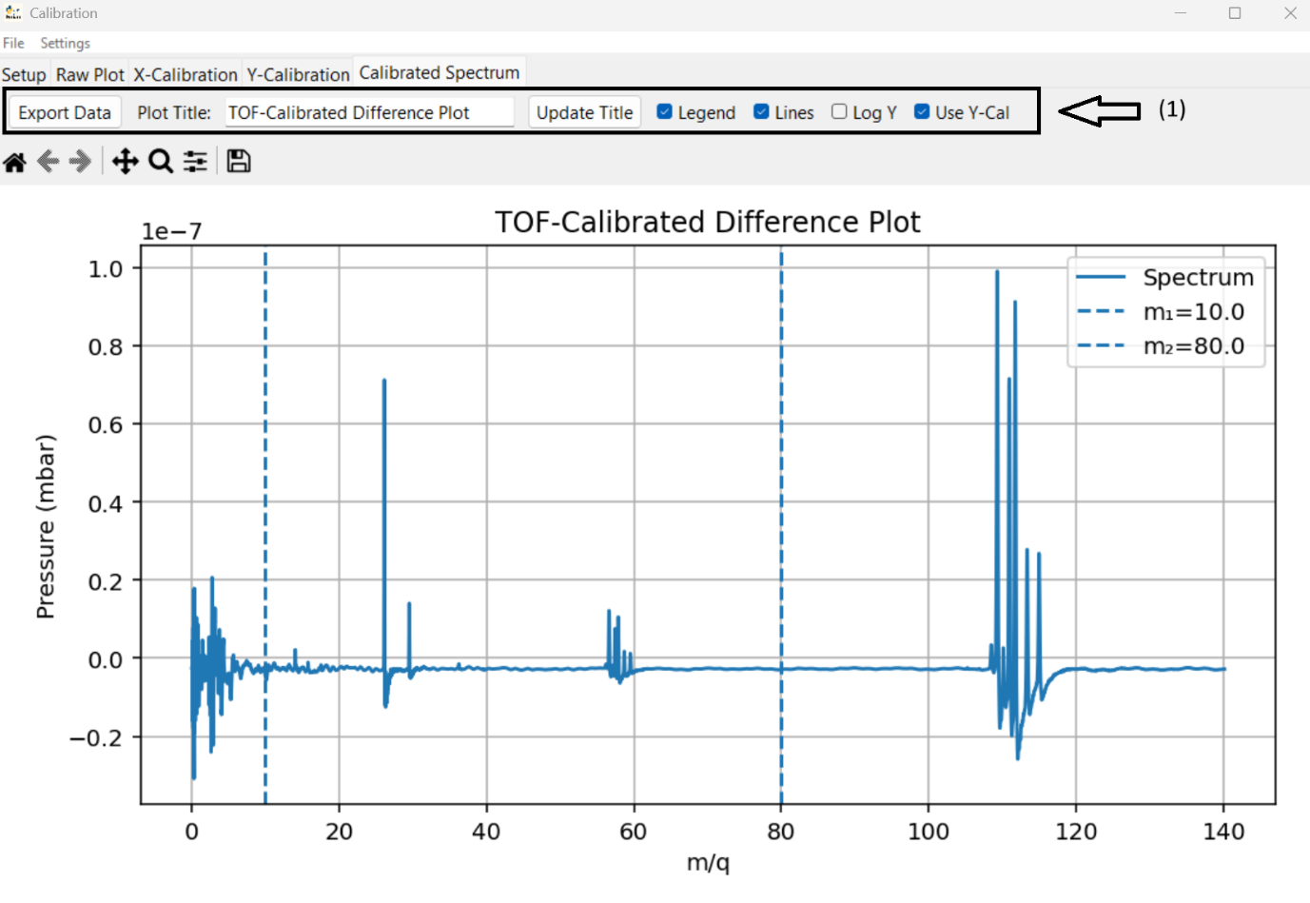

Figure 11: Calibrated Spectrum tab of Calibration